**Lab 2 DeMorgan’s Theorem Verification**

The objective of this lab is to build circuits to verify the DeMorgan’s Laws.

**Chips:**  74HCT**08** Quad 2-input AND gate, 74HCT**32** Quad 2-input OR gate, 74HCT**04** inverter

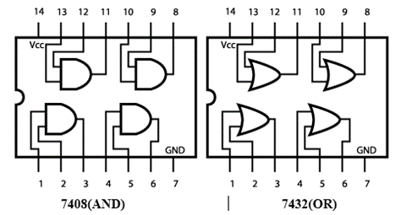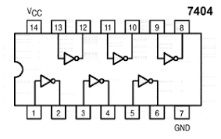

**Procedure**

Design a circuit with AND, OR and NOT gates that will prove the DeMorgan's Laws:

(X+Y)’ = X’ Y’ (XY)’ = X’ + Y’

1. Derive the truth table:

|  |  |  |  |  |
| --- | --- | --- | --- | --- |
| X Y | F1=(X+Y)’ | F2=X’Y’ | F3=(XY)’ | F4=X’+Y’ |
| 0 0 | 1 | 1 | 1 | 1 |
| 0 1 | 0 | 0 | 1 | 1 |
| 1 0 | 0 | 0 | 1 | 1 |
| 1 1 | 0 | 0 | 0 | 0 |

1. Draw the logic diagram

1. Circuit Construction on Tinkercad

The circuit can be built with one 7408 AND chip, one 7432 OR chip, and one 7404 inverter chip. DIP switches will be used to supply the two input logic levels X and Y, and LEDs will be used to provide readout of the four output bits F1 - F4.

1. After you log into the Tinkercad, copy and paste the following link to your web browser <https://www.tinkercad.com/things/19XqriP2dMF>. Click on the button of “Copy and Tinker” on the right to make a copy of the CSC 347 starter circuit and rename as “Lab 2”.
2. For each chip (08, 32, 04), connect its pin 14 to the power, and pin 7 to the ground.
3. Connect the chips together according to the schematic diagram obtained in Step 2.
4. Connect the inputs (X, Y) to two switches, and the outputs (F1, F2, F3, F4) to four LEDs. (Remember that you can only use the holes in the lower half of the breadboard for the LEDs and Switches)
5. Press “Start Simulation”

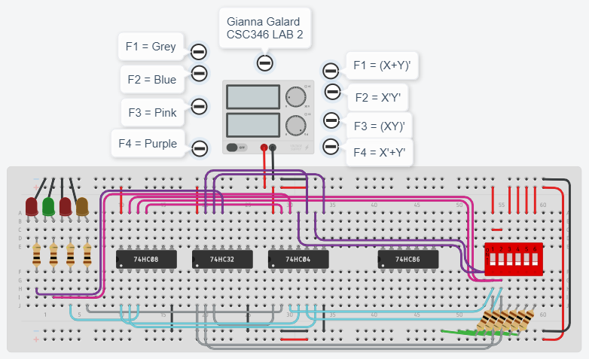

https://www.tinkercad.com/things/eJIg8HTydH1-copy-of-csc-347-starter-kit/editel?sharecode=Co85fg01GpKUbt3fGqaLRBm_9lkt9Elwa0dPVoz0pxE

1. Experiment:

Apply all four combinations of logic LOW and HIGH levels to the two gate inputs using the DIP switches. Observe the outputs, and record the results in the following table, in the form of 0s and 1s. Verify if your table matches with the truth table shown obtained in the first page.

|  |  |  |  |  |
| --- | --- | --- | --- | --- |
| X Y | F1=(X+Y)’ | F2=X’Y’ | F3=(XY)’ | F4=X’+Y’ |
| 0 0 | 1 | 1 | 1 | 1 |
| 0 1 | 0 | 0 | 1 | 1 |
| 1 0 | 0 | 0 | 1 | 1 |
| 1 1 | 0 | 0 | 0 | 0 |

1. Homework: Design a circuit to prove the Distributive Laws using TinkerCad and include it (equation, truth table, logic diagram, screenshot of circuit) in your lab report.

A(B + C) = AB + AC A + BC = (A + B)(A + C)

**Submission Instructions:**

Lab work submission

1. Take screenshots of your circuit working on each of the 4 input combinations. Remember you can take a screenshot of your circuit by clicking on “Share” ->”Snapshot of your design” at the top right corner.
2. Copy the link of your circuit for sharing (click on “Share” -> “Invite people” ->”Copy”)
3. On the Blackboard, click on Lab 2. Attach the screenshots from Step 1 and paste the link from Step 2 into the Comments area, then hit Submit button.

Lab report submission

Lab report is needed for this lab. Please follow the guidelines and sample report on the Blackboard when you are writing your lab report. Click on **Lab 2 Report Submission** to submit your report. It is due one week after the lab is done.